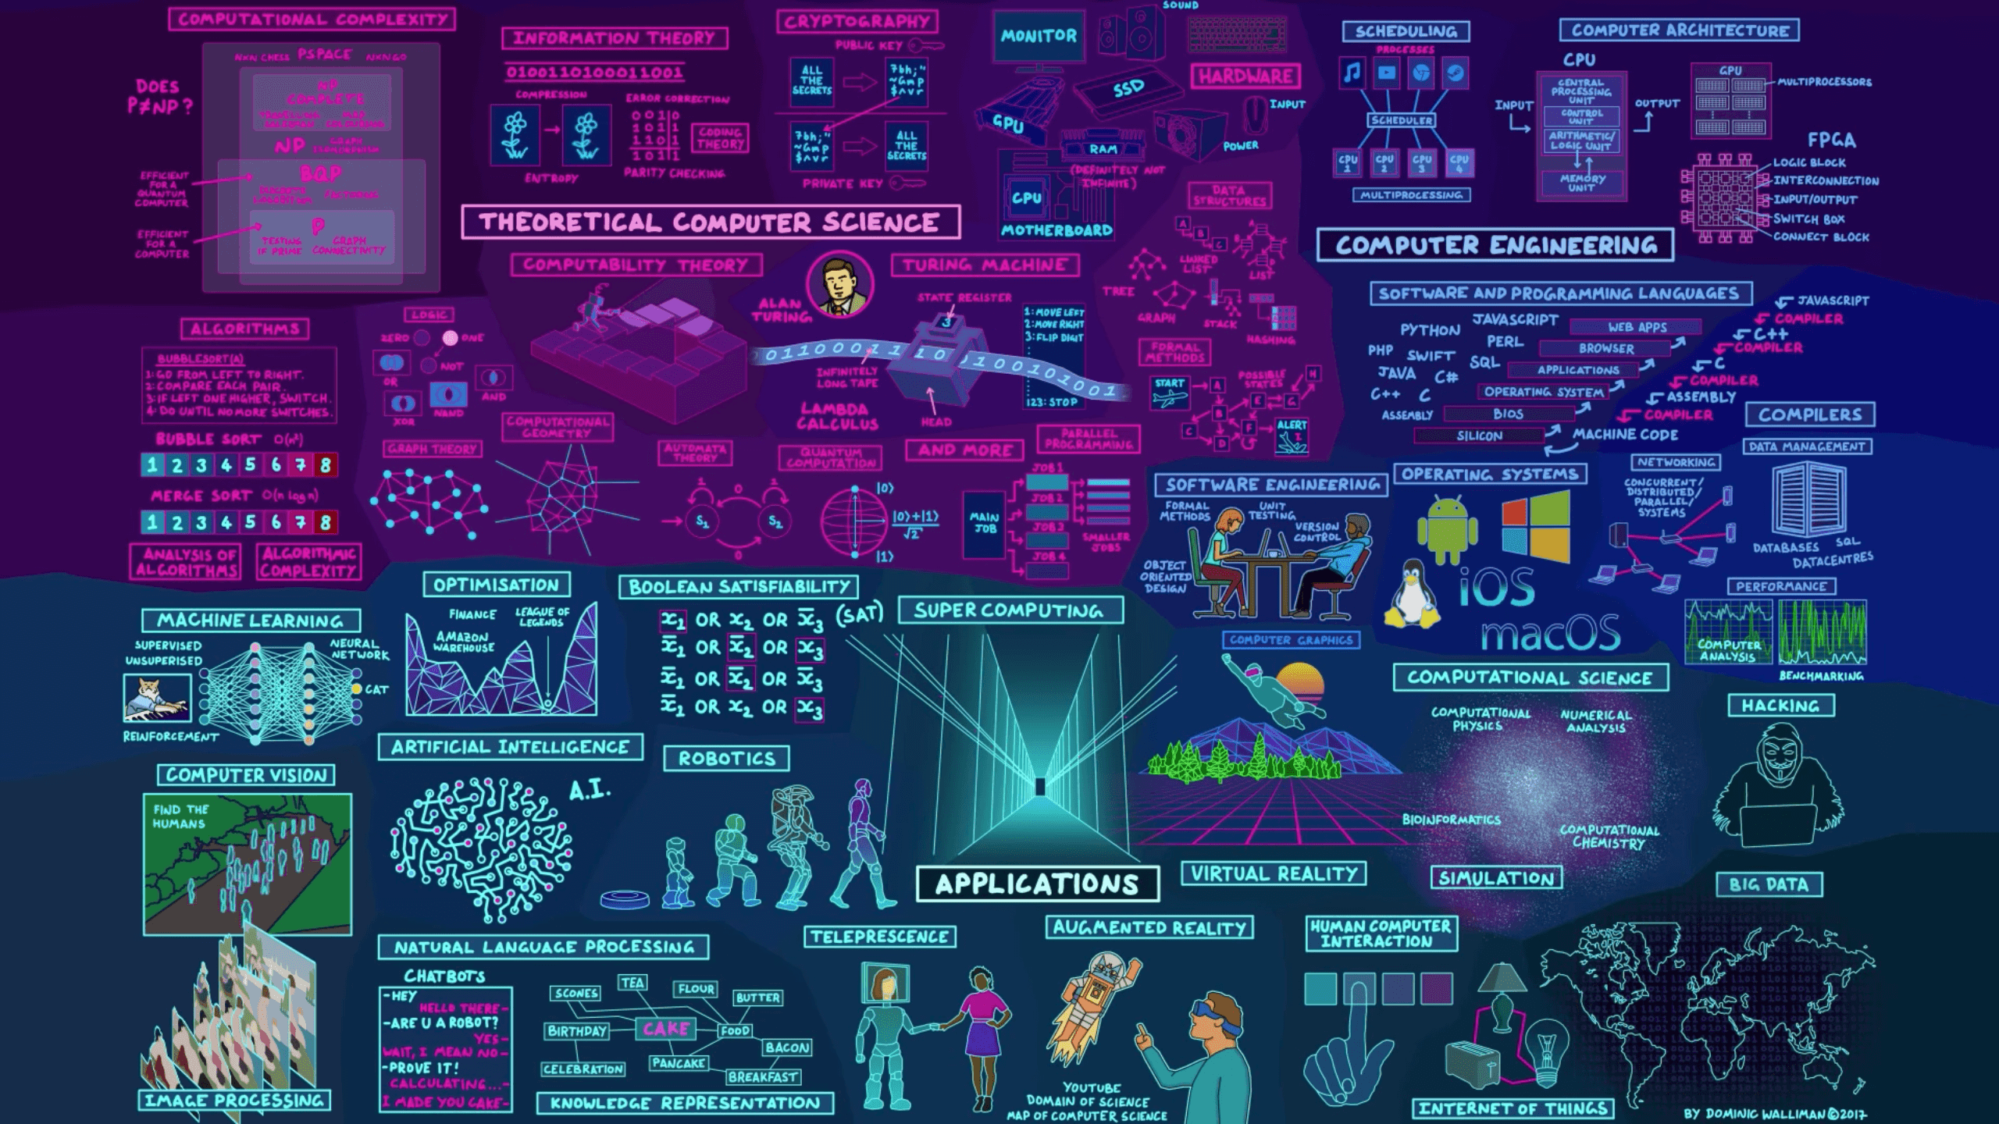
Name: | Waleed Afzal
Course: | Software Engineering
Roll Number: | 23P-0566
Section: | 5C
Assignment No: | #02
Date: | 30/10/25 – 2/10/25

Question 1:
Task1: CLASS DIAGRAM
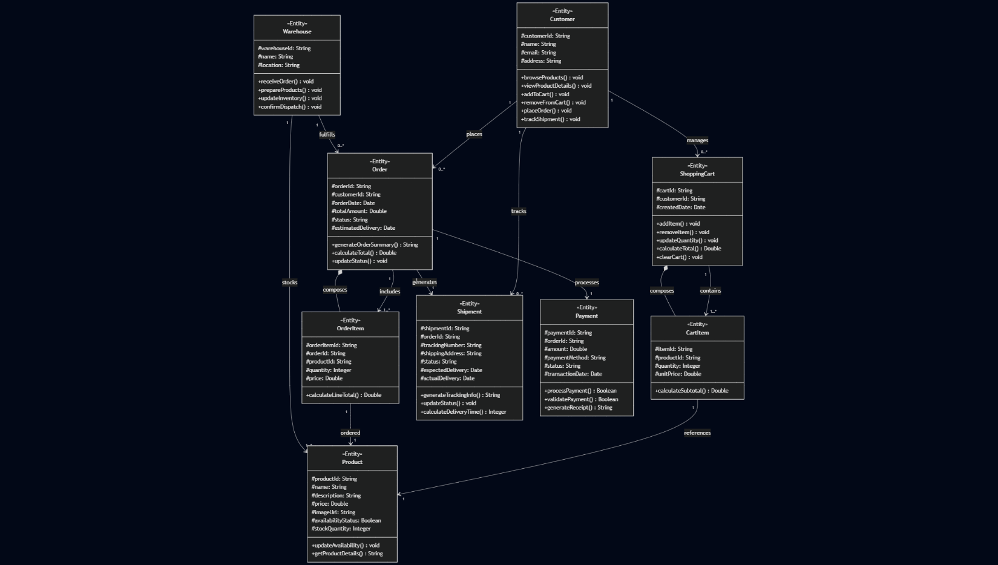
TASK2: GRASP DESIGN PATTERNS:

Creator Pattern Responsibilities
ShoppingCart creates CartItem
- Reason: ShoppingCart contains CartItems, aggregates CartItems, and has initial data for creating CartItems
Order creates OrderItem
- Reason: Order contains OrderItems, aggregates OrderItems, and has initial data for creating OrderItems
Customer creates ShoppingCart
- Reason: Customer uses ShoppingCart and has initial data for creating ShoppingCart
Information Expert Responsibilities
Primary Information Experts:
Customer (Information Expert for customer-related data)
- Knows: customerId, name, email, address
- Does: browseProducts(), viewProductDetails(), trackShipment()
- Reason: Has all the customer information needed for these operations
ShoppingCart (Information Expert for cart calculations)
- Knows: cartId, customerId, createdDate, collection of CartItems
- Does: calculateTotal()
- Reason: Has all CartItems needed to calculate total cost
CartItem (Information Expert for line item calculations)
- Knows: productId, quantity, unitPrice
- Does: calculateSubtotal()
- Reason: Has all information needed to calculate line item total (quantity × unitPrice)
Order (Information Expert for order processing)
- Knows: orderId, customerId, orderDate, totalAmount, status, estimatedDelivery
- Does: generateOrderSummary(), calculateTotal(), updateStatus()
- Reason: Has all order information needed for these operations
OrderItem (Information Expert for order line calculations)
- Knows: orderItemId, orderId, productId, quantity, price
- Does: calculateLineTotal()
- Reason: Has all information needed to calculate order line total
Product (Information Expert for product information)
- Knows: productId, name, description, price, availability, stock
- Does: getProductDetails(), updateAvailability()
- Reason: Has all product information
Shipment (Information Expert for delivery tracking)
- Knows: shipmentId, orderId, trackingNumber, status, expectedDelivery
- Does: generateTrackingInfo(), calculateDeliveryTime(), updateStatus()
- Reason: Has all shipment tracking information
Payment (Information Expert for payment processing)
- Knows: paymentId, orderId, amount, paymentMethod, status
- Does: processPayment(), validatePayment(), generateReceipt()
- Reason: Has all payment information needed for processing

Warehouse (Information Expert for inventory management)
- Knows: warehouseId, name, location
- Does: updateInventory(), confirmDispatch()
- Reason: Has warehouse information and manages inventory
High Cohesion Responsibilities
ShoppingCart - High cohesion for cart management
- Related responsibilities: addItem(), removeItem(), updateQuantity(), clearCart(), calculateTotal()
Order - High cohesion for order management
- Related responsibilities: generateOrderSummary(), calculateTotal(), updateStatus()
Product - High cohesion for product management
- Related responsibilities: updateAvailability(), getProductDetails()
Low Coupling Analysis
Well-decoupled relationships:
- CartItem knows Product but only through productId reference
- OrderItem knows Product but only through productId reference
- Warehouse knows Product for inventory management
- Customer knows ShoppingCart, Order, Shipment but these are natural dependencies
Controller Responsibilities
Customer class acts as a Controller for user interactions:
- browseProducts(), viewProductDetails(), addToCart(), removeFromCart(), placeOrder(), trackShipment()
Pure Fabrication (if needed for future extension)
Potential additional classes that could be created:
- OrderProcessor: To handle complex order validation and processing logic
- InventoryManager: To handle complex inventory operations across multiple warehouses
- NotificationService: To handle email/SMS notifications for order updates

TASK3: APPLY COUPLING AND COHESION PRINCIPLES:

Improvements for Coupling and Cohesion:
Reduced Coupling:
- Separation of Concerns: Split monolithic classes into focused services
- Interface Segregation: Each service has specific, focused responsibilities
- Dependency Injection: Services depend on interfaces rather than concrete implementations
- Data vs Behavior Separation: Pure data classes separated from service classes
High Cohesion:
- CartManager - Only cart operations (add/remove/update items)
- PricingCalculator - Only price calculations (SRP - Single Responsibility)
- OrderProcessor - Only order processing logic
- PaymentProcessor - Only payment handling
- InventoryManager - Only inventory operations
- ShipmentTracker - Only shipment tracking

TASK3: REDRAW DIAGRAM AFTER APPLYING COUPLING AND COHESION:
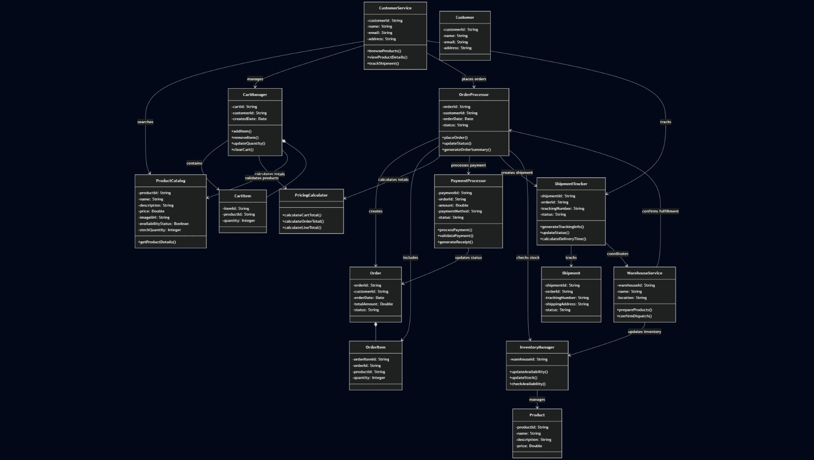
Question 2:
SCENARIO 1:--
TASK1:
Identified Design Patterns:
- Builder Pattern - For constructing different types of pizzas step by step
- Factory Method Pattern - For creating different pizza types
- Decorator Pattern - For adding toppings dynamically (if needed for flexibility)
The Builder Pattern is most suitable here because:
- We need to construct complex objects (pizzas) with different configurations
- The construction process involves multiple steps
- We want to separate construction from representation
UML Diagram:
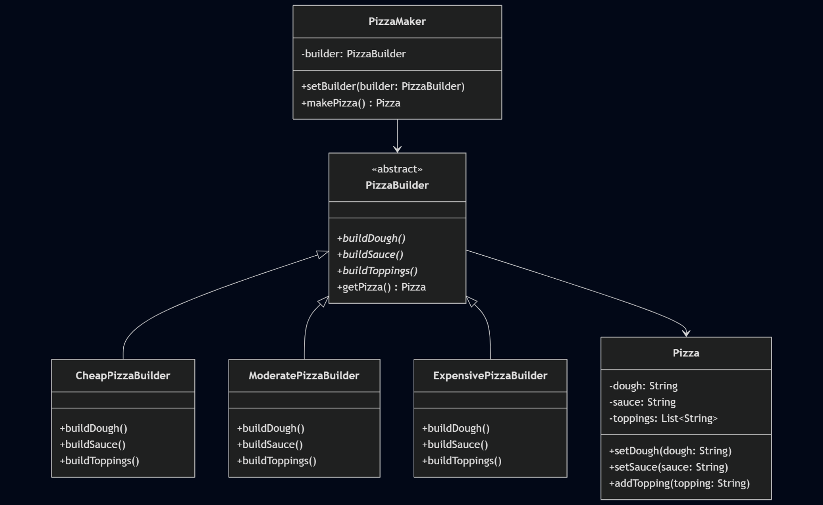
TASK2:
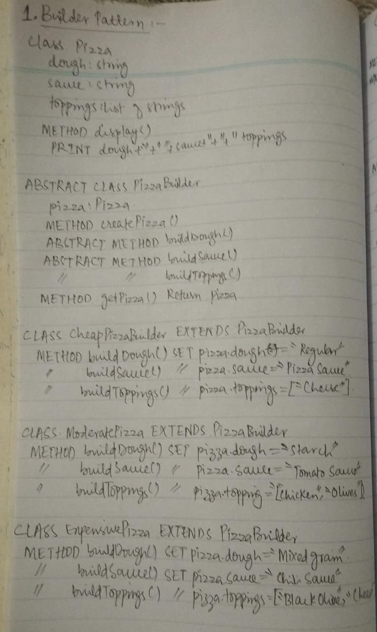
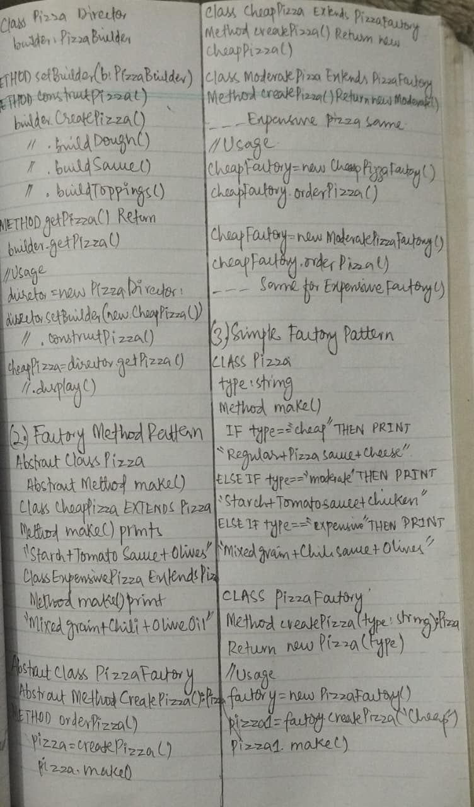
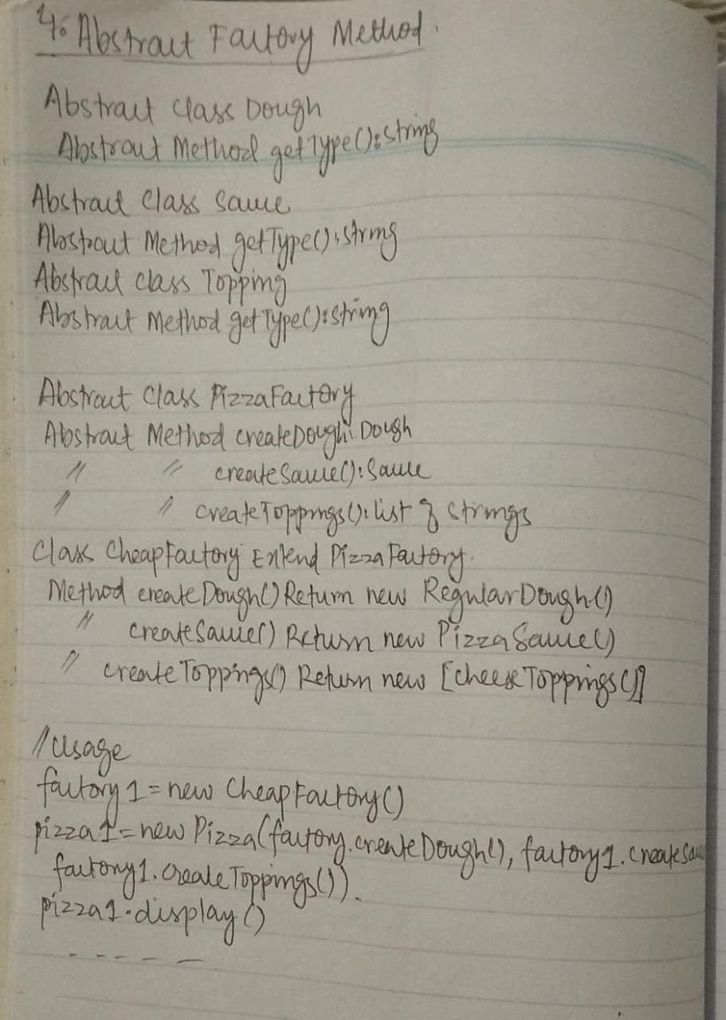

SCENARIO 2:--
TASK1:
Identified Design Patterns:
Primary Pattern: Decorator Pattern - Perfect for adding services dynamically to room bookings
Secondary Pattern: Factory Method Pattern - For creating different room types
Additional Pattern: Strategy Pattern - For different pricing strategies (if needed)
Primary Pattern UML:
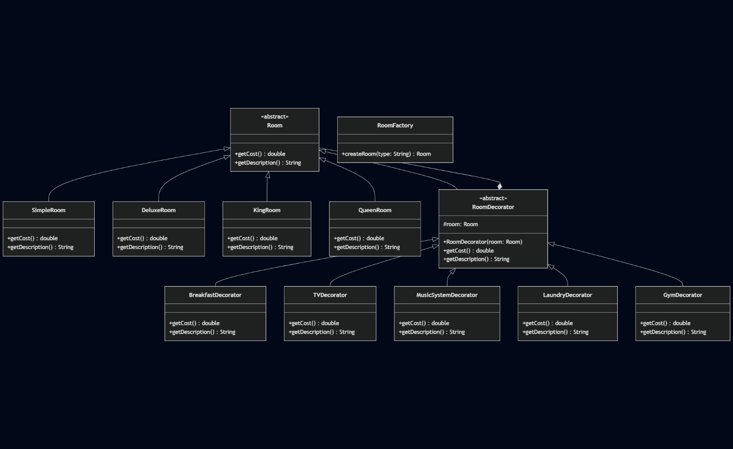
Alternative Pattern UML (Factory + Strategy):
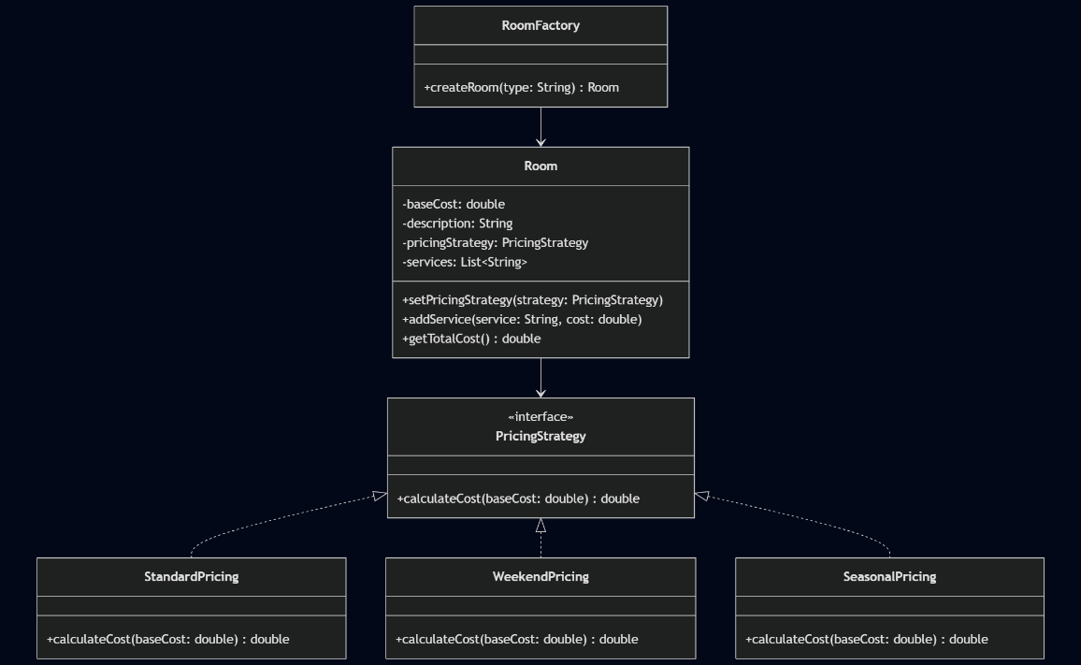
TASK2:
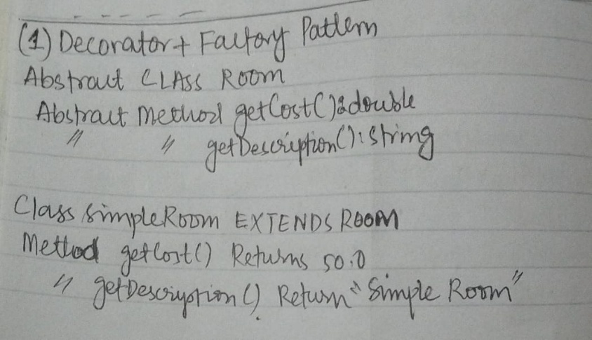
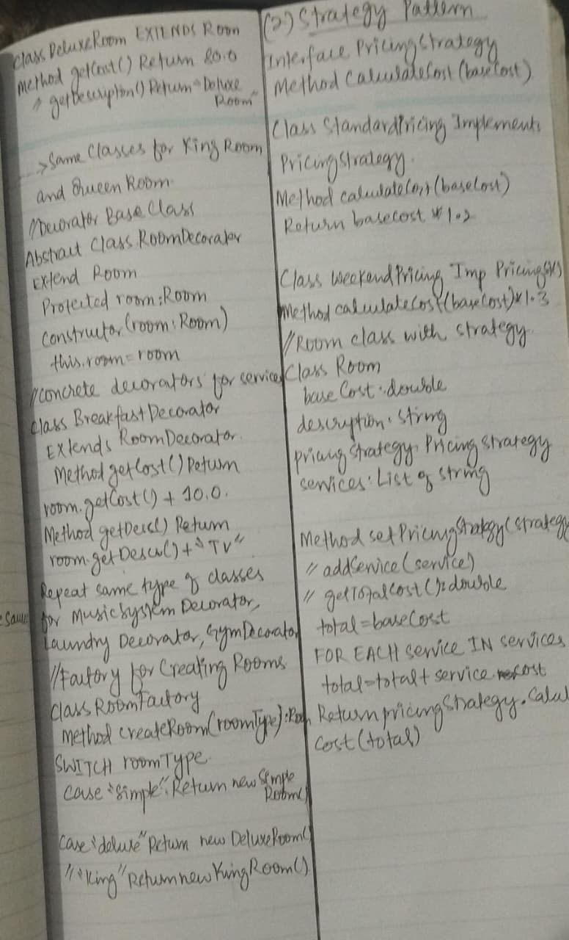
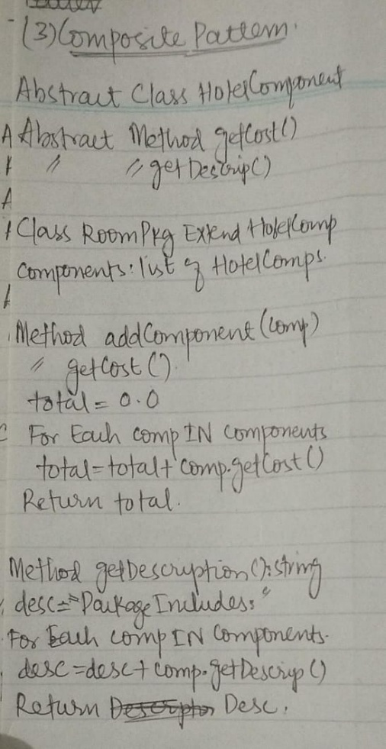
SCENARIO 3:--
TASK1:
Identified Design Patterns:
Primary Pattern: State Pattern - Perfect for handling order state transitions with specific behaviors for each state
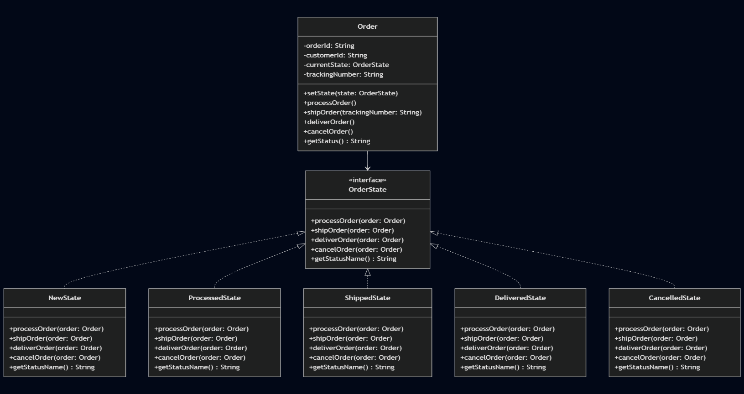
TASK2:
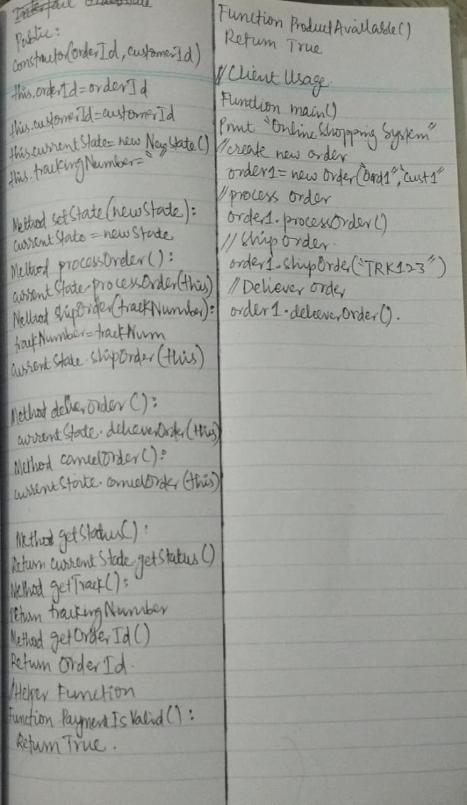
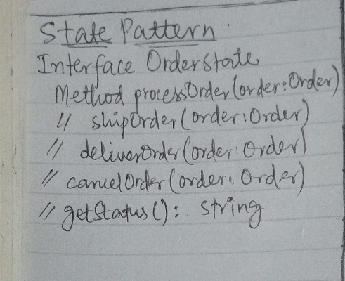
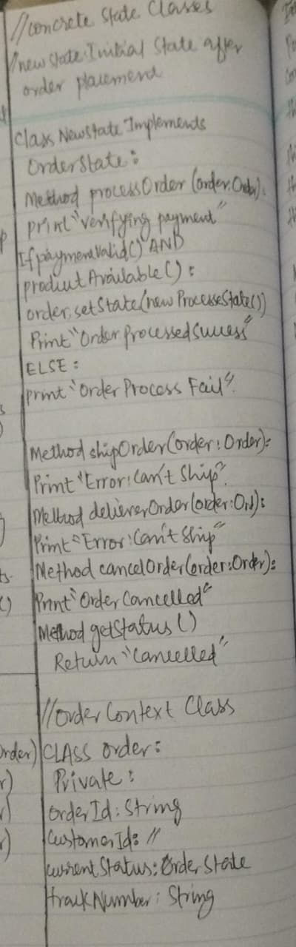
Question 3:
Pipeline architecture
